
Symbiosis Institute of Technology, Pune
Faculty of Engineering
CSE- Academic Year 2026-27
Java Programming – Lab Batch 2024-28
Lab Assignment No:- 16
Name of Student: Sanika Botre
PRN No.: 25070122063
Batch: 2025-29
Class: CSE A-2
Academic Year & Semester: 2026 & 3rd Semester
Date of Submission
Title of Assignment: Write a Java program to create and handle a user-defined exception.

Learning Objectives: To create and implement custom exceptions for application-specific error handling.

Theory:
User-defined exceptions are created by extending the Exception class. They allow developers to define meaningful exceptions for specific business logic. Custom exceptions improve program readability and simplify debugging by providing descriptive error messages. They are widely used in enterprise software and validation systems.
Practice questions
1. Create a Voting System that throws a custom exception if age is below 18.

Code:
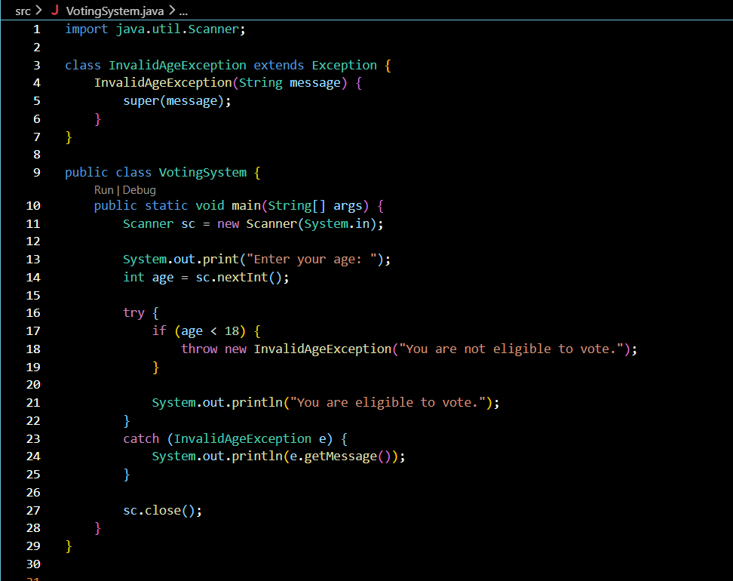

Output:
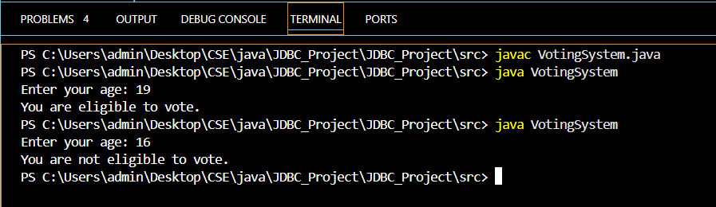

2. Create a Driving License System that throws a custom exception if the user’s age is below 18. If the age is valid, display that the user is eligible for a driving license.

Code:
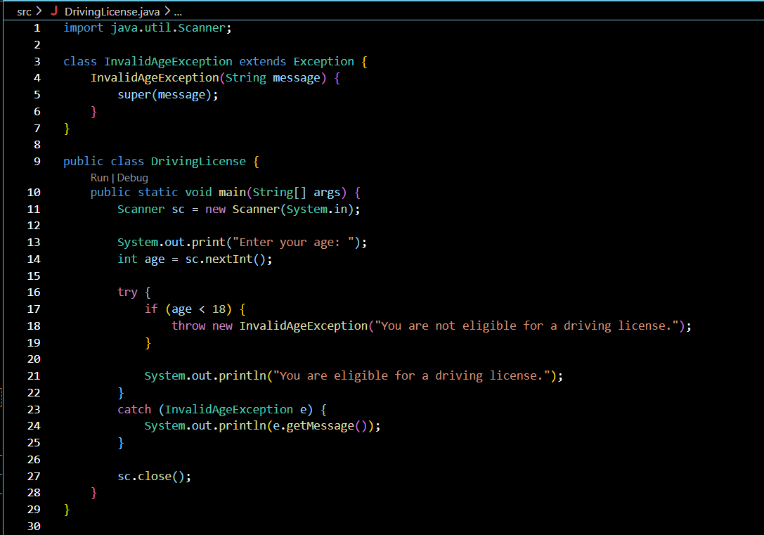

Output:
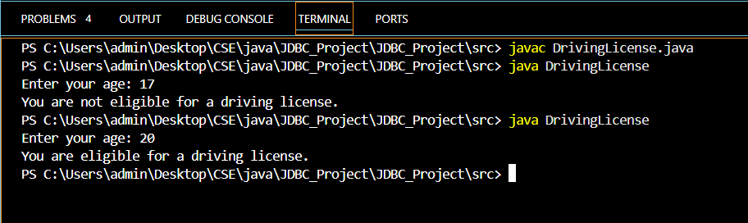

Conclusion:

Thus, the Voting System and Driving License System were successfully implemented using user-defined exceptions in Java. A custom InvalidAgeException was created and thrown when the user’s age was below 18. For users aged 18 or above, the programs successfully displayed that they were eligible. This demonstrates the use of custom exception classes, throw, and try-catch for handling invalid conditions.

